EXPERIMENT 4
7 SEGMENT DISPLAY USING AT89C51 USING PROTEUS
AIM: To write an assembly language program for 7 Segment Display using AT89C51 using Keil and Proteus.
SOFTWARE REQUIRED: Proteus 8 software
ALGORITHM
- Send the segment code for digit 0 to Port 2.
- Delay and send the codes for digits 1 through 9.
- Use a nested delay routine to keep each digit visible.
- Repeat continuously.
PROGRAM
ORG 000H
UP: MOV P2,#0C0H
ACALL DELAY
MOV P2,#0F9H
ACALL DELAY
MOV P2,#0A4H
ACALL DELAY
MOV P2,#0B0H
ACALL DELAY
MOV P2,#099H
ACALL DELAY
MOV P2,#092H
ACALL DELAY
MOV P2,#082H
ACALL DELAY
MOV P2,#0F8H
ACALL DELAY
MOV P2,#080H
ACALL DELAY
MOV P2,#090H
ACALL DELAY
DELAY: MOV R5,#10
H1: MOV R4,#180
H2: MOV R3,#255
H3: DJNZ R3,H3
DJNZ R4,H2
DJNZ R5,H1
RET
END
OUTPUT IMAGE

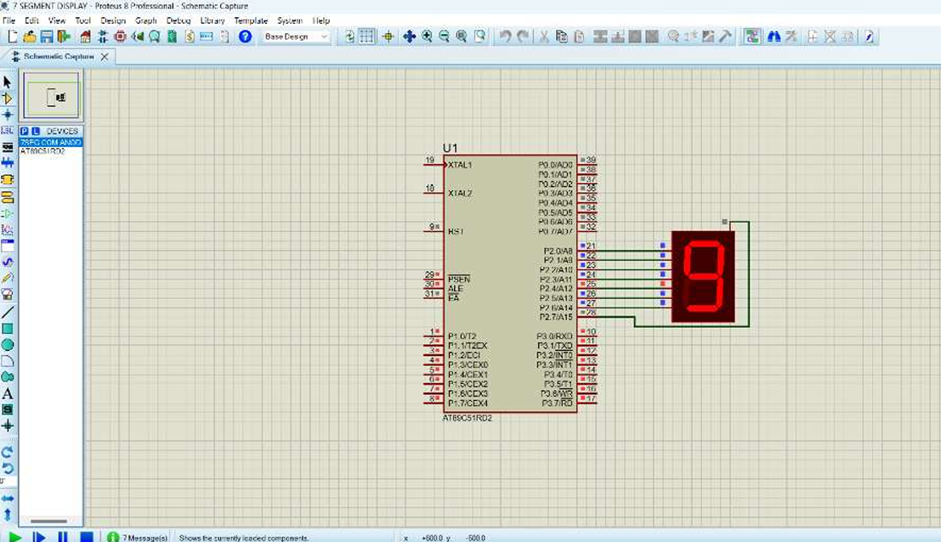
RESULT
Thus the program has been successfully verified and executed.

